**José Antonio López World Guitar Competition**

**Description**

The primary objective of the ***José Antonio López World Guitar Competition*** is to celebrate and reward artistic expression and musicality in classical guitar performance.

With $16,000 in prizes, the competition aims to inspire guitarists worldwide to revive the lyricism and tonal richness that define classical guitar. It also seeks to rekindle the interpretative styles popularized by legendary figures such as Julian Bream (England), Alirio Díaz (Venezuela), and Leonardo Egúrbida (Puerto Rico).

The competition will take place as part of the **Festival Mundial de la Guitarra**, a global event celebrating the art of guitar, featuring some of the world's most renowned luthiers. For the 2025 edition, participants will include Andrea Tacchi (Italy), Gerhard Oldiges (Germany), Gerardo Escobedo (Mexico), Alberto Martínez from *Orfeo Magazine* (Uruguay/Paris), and the distinguished collector José Luis Postigo (Seville, Spain).

The festival’s featured concerts will include a performance by GFA winner Leonela Alejandro (Puerto Rico). Additionally, two *Café Concerts* titled *"Guitar Tasting"* will be presented, featuring virtuoso guitarists Iván Rijos (Puerto Rico) and Marcus Toscano (Brazil). To further enrich this grand international gathering, a series of masterclasses conducted by guest artists will also be offered.

**Location**

The ***José Antonio López World Guitar Competition*** will be held in Mayagüez, Puerto Rico.

**Date: Saturday, May 3, 2025.**

**Prizes:**

1st Place: $5,000  
2nd Place: $2,000  
3rd Place: $1,000

**Audience Award:** This prize will be awarded for the best performance of the required piece, *"Guitarra Poética,"* composed by José Antonio López. The award consists of a "Replica of Antonio de Torres" concert guitar, valued at $5,000, crafted by the world-renowned luthier Gerardo Escobedo from Paracho, Mexico.

**Required Piece**

The competition requires each contestant to perform the piece *"Guitarra Poética"* (Homage to Manuel Bellido) composed by Puerto Rican composer José Antonio López. The PDF score, audio samples, and several YouTube videos will be available for download on the event's official website.

**Age**

The José Antonio López World Guitar Competition is an open-category event with no age restrictions for participation.

**Preliminary Round**

The ***José Antonio López World Guitar Competition*** begins with an initial elimination phase, which requires contestants to perform the mandatory piece titled *“Guitarra Poética.”* This performance must be submitted as a YouTube video no later than March 30, 2025.

In the video, each contestant must include a brief personal introduction before the performance, stating their full name, country of origin, the name of the competition, and the title of the piece.

Additionally, participants must submit the registration form, which can be downloaded from the official website, along with the video link. Both the video link and the registration form should be sent to the following email address:

[jalworldguitarcompetition@gmail.com](mailto:jalworldguitarcompetition@gmail.com)

Registration form: Click Here

**Final Stage**

The final stage of the ***José Antonio López World Guitar Competition*** will take place in person on May 3, 2025, in Puerto Rico.

During the first round of the final stage, the three finalists, selected in alphabetical order, will perform the required piece, *"Guitarra Poética"* by José Antonio López. In the second round, the finalists will present a free-choice repertoire with a maximum duration of 20 minutes. The repertoire selection and interpretative approach must align with the competition’s guidelines.

**Stipend for Finalists**

Flights

The three selected finalists will each receive a $500 stipend to assist with their flight expenses. (Please note that, as Puerto Rico is a U.S. territory, each contestant must ensure they meet the necessary visa requirements for entry into the United States.) When booking airline tickets, it is recommended to fly into San Juan Airport.

**Hotel and Transportación**

The ***José Antonio López World Guitar Competition*** will provide three nights of accommodation for the three finalists, along with internal transportation. Additionally, the day after the competition, we will organize a trip to the beautiful beaches of Puerto Rico (as the one in the poster) for all participants of the World Guitar Festival. Please note that Puerto Rico enjoys a single season throughout the year: summer!

**International Jury**

The ***José Antonio López World Guitar Competition*** has appointed renowned artists from the international music scene as members of the jury. The distinguished panel includes Pablo Martos (violinist) and Alberto Martos (cellist) from Spain, Alfredo Minetti (pianist) from Uruguay, and Richard Scofano (composer and bandoneonist) from Argentina.

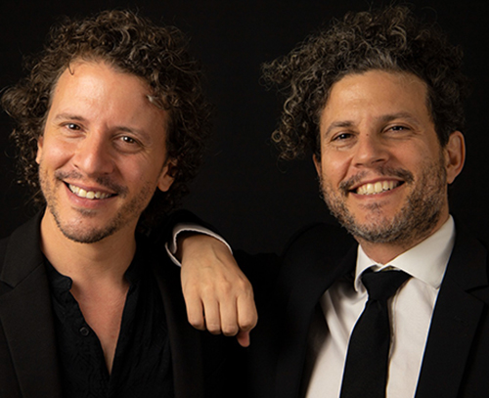

Cellist Alberto Martos and violinist Pablo Martos (Spain)

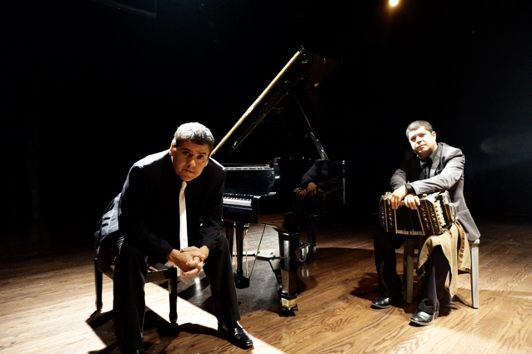

Alfredo Minetti, pianist (Uruguay), and composer and bandoneonist Richard Scofano (Argentina).

(It is important to note that the jury members will follow the competition from their respective countries via a live broadcast on YouTube).

**José Antonio López**

Retired concert guitarist José Antonio López holds a Doctorate from the prestigious Indiana University School of Music, a Master’s degree from Arizona State University, and a Bachelor’s degree from the Conservatory of Music of Puerto Rico.

With a distinguished career spanning more than 30 years as a guitar soloist, he is recognized for his performances with major symphony orchestras throughout the Americas. Through his **Centro de Estudios Guitarrísticos** in Puerto Rico, he has mentored an entire generation of virtuoso guitarists who now dominate the contemporary Puerto Rican guitar scene.

As a professor and researcher at the University of Puerto Rico at Mayagüez, he has made significant contributions to the field, including an extensive discography and numerous publications on concert guitar and the bolero genre. His most ambitious project to date is an encyclopedia on Juan Neri and the trio *Los Tres Ases,* which will also feature an accompanying documentary film.

Currently retired from performing and teaching, he devotes his time entirely to composition and traveling the world in search of his dream guitar. In 2020, he published *Opus 1, No.1*, a collection of 36 concert works for solo guitar.